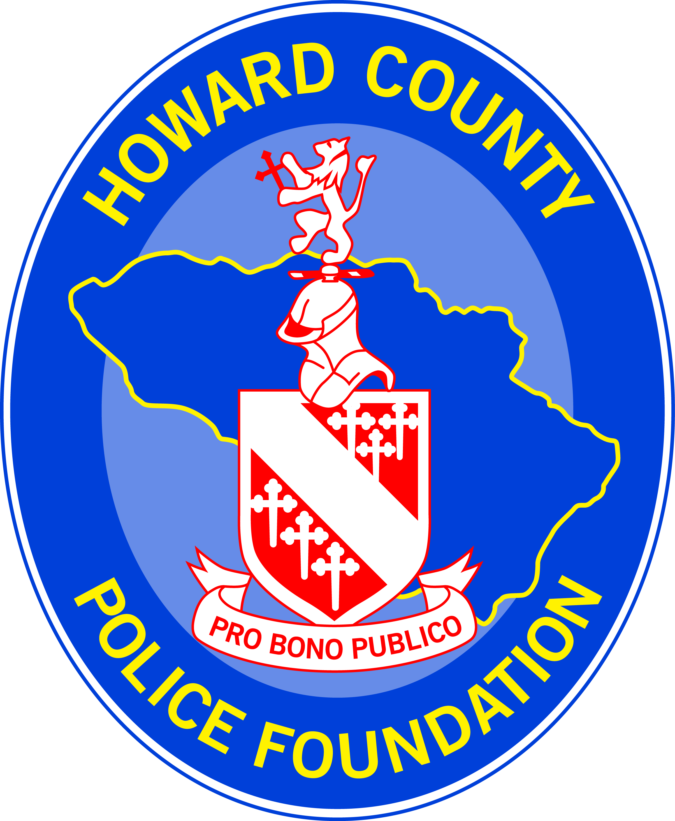

THE HOWARD COUNTY POLICE FOUNDATION

2024 Chiefs’ Continuing Education Scholarship

Name:
School Attending:

Degree/Certification being pursued:
Have you received this scholarship in the past?

- Explain why you should be considered for The HCPF Chiefs’ Continuing Education Scholarship?

- What is your current position and responsibility with the Howard County Police Department?

- Please provide information about any awards or recognition you have received.

- How will your education support your future career goals?

- How will your continued education support the mission of the Howard County Police Department?

- Is there any additional information you wish to share (i.e.: hobbies, interests, volunteer work, etc.)?

In addition to the questions above, you may provide one or two letters of
recommendation from your current or past HCPD supervisors.

Your signature below acknowledges you have read and understand the criteria for applying for the HCPF Chiefs’ Continuing Education Scholarship and certify that all the information contained in this application is true and accurate to the best of your knowledge.

Signature of Officer: |  | Date:

This application and letters of recommendation must be received by Friday, March 29, 2024.

The Howard County Police Foundation Scholarship Committee
c/o Roberta Campbell
Howard County Police Department
3410 Court House Drive
Ellicott City, MD 21043

