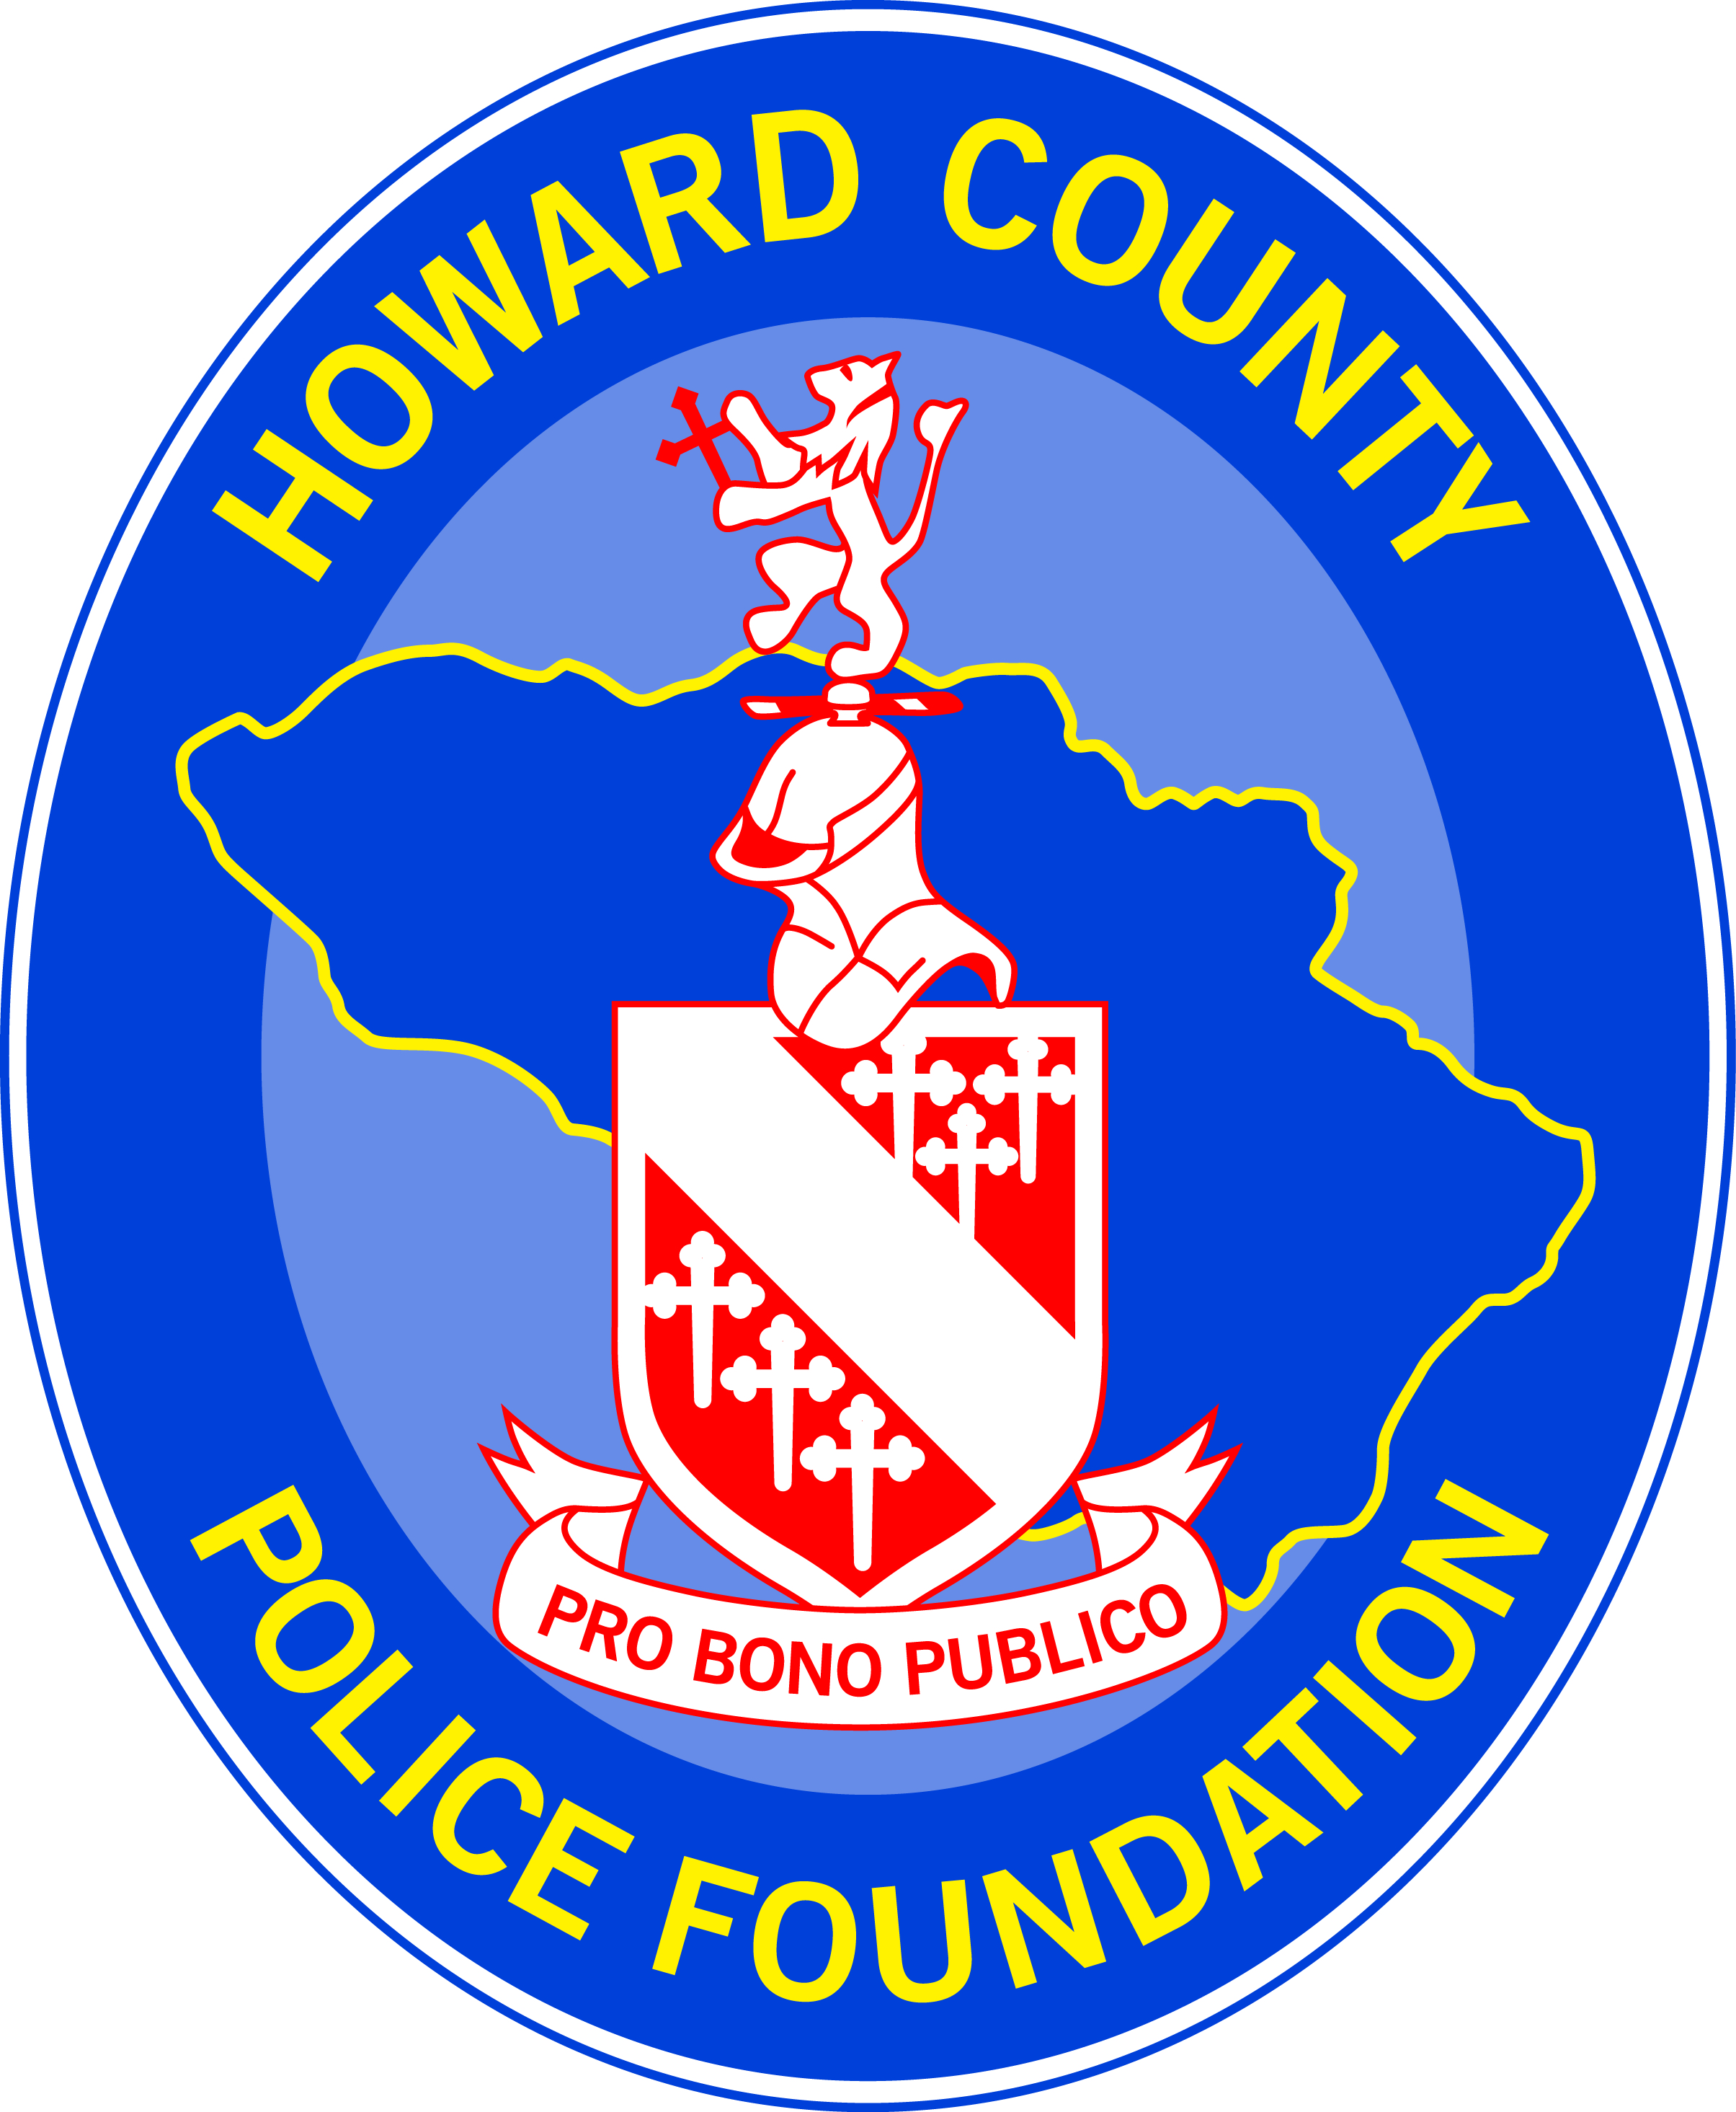

THE HOWARD COUNTY POLICE FOUNDATION

2023 STUDENT SCHOLARSHIP AWARD APPLICATION

Name: |  | High School
Home Address:
Home Number: |  | Cell Number:

- Why should you be considered for The Howard County Police Foundation Scholarship Award?

- What are your college plans?

- Please list extra-curricular school activities you have participated in.

- Please list community activities you have participated in.

- Please list awards or recognitions you have received.

- What are your hobbies and interests?

- Are you the son or daughter of a parent or legal guardian who is a current or former employee of the Howard County Police Department? ____Yes _____ No

If yes, name of HCPD employee:

Please include the following with your typed application:

- A school certified copy of your high school transcript. (sealed and mailed to the address below)
- Letters verifying participation in extracurricular events or a contact person (name and phone number) of activity coordinator.
- Up to five testimonials (letters from teachers, coaches, employers, community leaders and newspaper articles)

I have read and understand the criteria for applying for The Howard County Police Foundation Scholarship. I certify that all of the information contained on the application and enclosed required attachments are correct. I also certify that I am either a son/daughter of a parent/guardian of a current or former Howard County Police Department Employee or that I am a resident of Howard County.

Signature of Student: |  | Date:

This application form and required attachments must be received by Friday, March 31, 2023.

The Howard County Police Foundation Scholarship Committee
c/o Roberta Campbell
Howard County Police Department
3410 Court House Drive
Ellicott City, MD 21043

